**Project Design Phase-II**

**Data Flow Diagram & User Stories**

|  |  |
| --- | --- |
| Date | 03 October 2022 |
| Team ID | PNT2022TMID00684 |
| Project Name | Project – Intelligent Vehicle Damage Assessment & Cost Estimator for Insurance Companies |
| Maximum Marks | 4 Marks |

**Data Flow Diagrams:**

A Data Flow Diagram (DFD) is a traditional visual representation of the information flows within a system. A neat and clear DFD can depict the right amount of the system requirement graphically. It shows how data enters and leaves the system, what changes the information, and where data is stored.

**Flow Chart:**

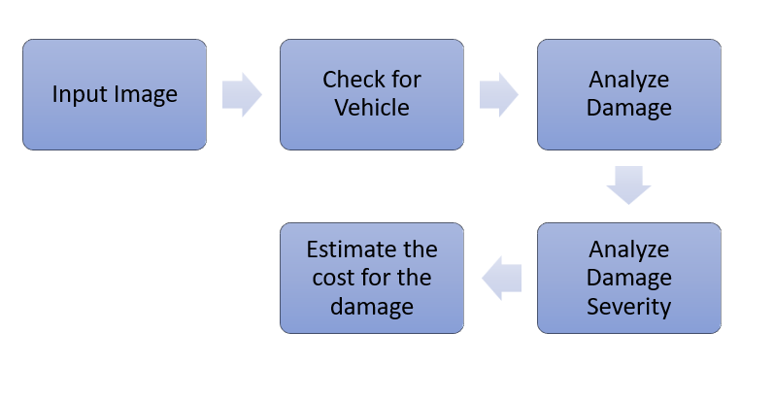

**User Stories**

Use the below template to list all the user stories for the product.

| **User Type** | **Functional Requirement (Epic)** | **User Story Number** | **User Story / Task** | **Acceptance criteria** | **Priority** | **Release** |
| --- | --- | --- | --- | --- | --- | --- |
| Customer | Registration | USN-1 | As a user, I can register for the application by entering my email, password, and confirming my password. | I can access my account / dashboard | High | Sprint-1 |
|  |  | USN-2 | As a user, I will receive confirmation email once I have registered for the application | I can receive confirmation email & click confirm | High | Sprint-1 |
|  |  | USN-3 | As a user, I can register for the application through Facebook | I can register & access the dashboard with Facebook Login | Low | Sprint-2 |
|  |  | USN-4 | As a user, I can register for the application through Gmail | I can register & access the dashboard with Gmail Login | Medium | Sprint-1 |
|  | Login | USN-5 | As a user, I can log into the application by entering email & password | I can register & access the dashboard by entering Email & Password Login | High | Sprint-1 |
|  | Dashboard |  |  |  |  |  |
| Customer | Import Images | USN-6 | As a user, after logging in, import the images of the vehicle damage | I can Upload the images of damaged vehicle in the website | High | Sprint-1 |
|  |  |  |  |  |  |  |
| Customer Care Executive | Address user problems | USN-1 | As a Customer Care Executive, I can address the user problems regarding the website if the it does not work properly | I can address the problems of the customer | Low | Sprint-2 |
| Administrator | Working of Website | USN-1 | As a Administrator, I make sure that the website works properly and make any changes , update the website if necessary | I can make sure that website works properly | High | Sprint-1 |